Name: ____________________ Date: __________ Period: _____________
Interpersonal Relationships
Vocabulary Set #1
Objective 1.01: Understand the unique characteristics of self.

Directions: Please complete the following vocabulary squares like the example given. Please use pages 13-24 in the textbook Building Life Skills for the correct definition of each word. Submit in the Google Classroom when you are finished.

Learning Style | the way a person learns best
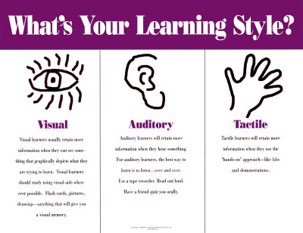 | The majority of my students are tactile learners because they learn better with hands on activities.

Traits

Personality Traits

Physical Traits

Environment

Self-confidence

Heredity

Character

Unique

